Student Name: __________________
Class and Section __________________
Total Points (20 pts) __________________
Due: October 24, 2016 before the class

Project: Binary Tree Traversal

CSCI 2410 Data Structures and Algorithms
Armstrong State University

Problem Description:

Modify Listing 25.10, TreeControl.java, to add three new buttons Show Inorder, Show Preorder, and Show Postorder to display the result in a message dialog box, as shown in the following figure. You need also to modify BinaryTree.java to implement the inorder(), preorder(), and postorder() methods so that each of these methods returns a List of node elements in inorder, preorder, and postorder, as follows:

public java.util.List<E> inorderList();
public java.util.List<E> preorderList();
public java.util.List<E> postorderList();

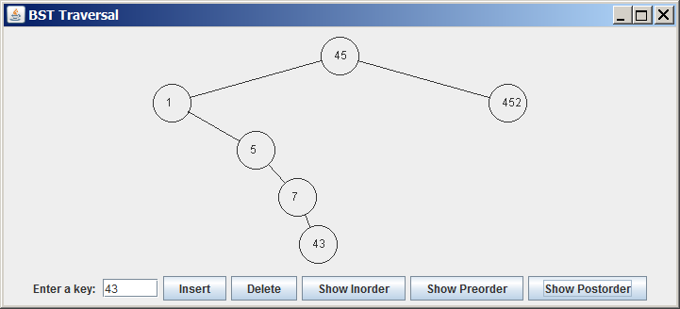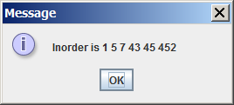

Figure
When you click the Show Inorder button in (a), the tree nodes are displayed in an inorder in a message dialog box in (b).

Coding:

Name your program Exercise25_13

Screen shots:

Submit the following items:

1. Compile and Submit to LiveLab (you must submit the program regardless whether it complete or incomplete, correct or incorrect)

2. Fill in self-evaluation:

- Can your program display inorder correctly? _______________
- Can your program display preorder correctly? _______________
- Can your program display postorder correctly? _______________

